**Project Specification Document**

**1.1 Project and Developer details**

“**Complaint Redressal System**” is a web-based application which contains data and information of lodge complaints and user details. The main purpose of “Complaint Management System” is to systematically record, store and update the complaints and user records.  
Complaint Management System is a management technique for assessing, analysing, and responding to customer complaints. Complaints management software is used to record resolve and respond to customer complaints, requests as well as facilitate any other feedback.

1. **Admin**: Admin have below rights to create new user:

* Customer
* Engineer
* Manager
* Create User: Show the registration page where new Customer, Engineer or Manager register, Lets create users like manager, customer, and Engineer
* Manager: Show All the Available manager.
* Customer: Show All the Available manager.
* Engineer: Show All the Available manager.

B) **Customer**: The Customer have below responsibility:

* Raise Complaint: Customer can raise new complaints using this option
* Show Complaints: Customer can show their complaints and there status as well provide feedback to the engineer and manager

C)**Manager**: The Manager have Below Responsibilities:

* Assign Engineer: Manager Can assign tickets to engineers
* Show Complaints: Manager can show all the registered complaints.
* All complaints: Manager can view all the assigned and unassigned complaints.
* Show Feedback: Manager can show feedback given by customer.

D)**Engineer**: The Engineer has below responsibilities

* Show Complaints: Engineer cam shows all assigned complaints and work on the all assigned tickets.
* Show Feeback: Engineer can show feedback given by customer.

**1.2 Developer Details:**

We have developed Complaint Redressal System in spring boot rest API and Angular JS. The main purpose of “Complaint Management System” is to systematically record, store and update the complaints and user records

**2. Spring Planning:**

**Task1: Admin**: Admin have below rights to create new user:

* Customer
* Engineer
* Manager
* Create User: Show the registration page where new Customer, Engineer or Manager register, Lets create users like manager, customer, and Engineer
* Manager: Show All the Available manager.
* Customer: Show All the Available manager.
* Engineer: Show All the Available manager.

**Task 2: Customer**: The Customer have below responsibility:

* Raise Complaint: Customer can raise new complaints using this option
* Show Complaints: Customer can show their complaints and there status as well provide feedback to the engineer and manager

**Task 3. Manager**: The Manager have Below Responsibilities:

* Assign Engineer: Manager Can assign tickets to engineers
* Show Complaints: Manager can show all the registered complaints.
* All complaints: Manager can view all the assigned and unassigned complaints.
* Show Feedback: Manager can show feedback given by customer.

**Task 4. Engineer**: The Engineer has below responsibilities

* Show Complaints: Engineer cam shows all assigned complaints and work on the all assigned tickets.
* Show Feeback: Engineer can show feedback given by customer.

**3. Flowchart:**

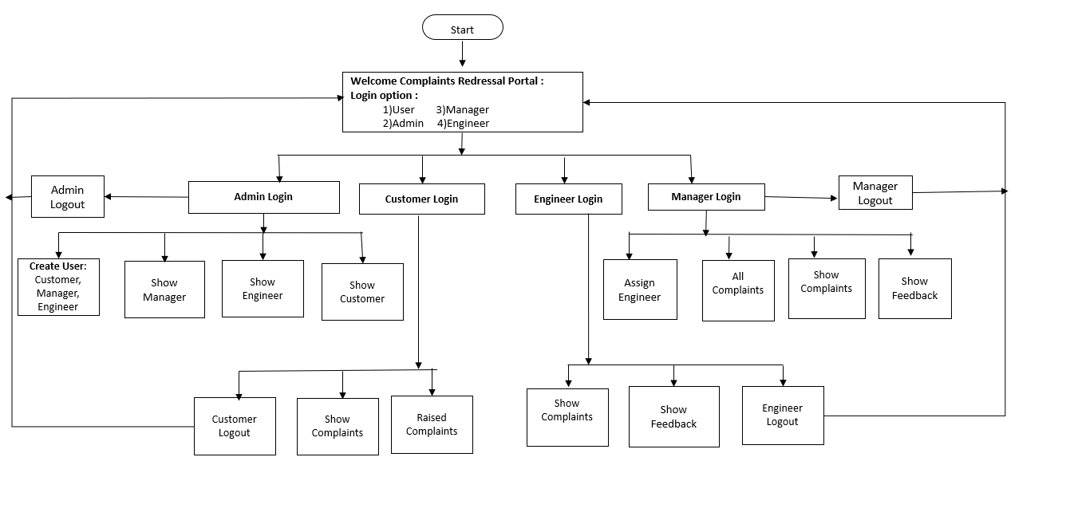

**4. Core concepts used in the project Concepts used in developing the application are**

**Front-End:** HTML, CSS, Angular JS, Bootstrap, JavaScript  
**Server-side:** Spring Boot Rest API, Spring Security   
**Back-end:** MYSQL, Hibernate.

**IDE**: Spring tool suite 4, Node JS

**5. Links to the GitHub repository to verify the project completion**